**Jenkins**

**Installation:**

* Jenkins Installation steps.
* wget -q -O - https://pkg.jenkins.io/debian/jenkins-ci.org.key | sudo apt-key add –
* echo deb https://pkg.jenkins.io/debian-stable binary/ | sudo tee /etc/apt/sources.list.d/jenkins.list
* sudo apt-get update
* sudo apt-get install Jenkins
* sudo systemctl start jenkins
* sudo systemctl status Jenkins
* login http://ip_address_or_domain_name:8080 [default port]

**Create new job**

* Click on 'New Item' link
* Give a new name for your job
* Select Project type
* Click 'OK'

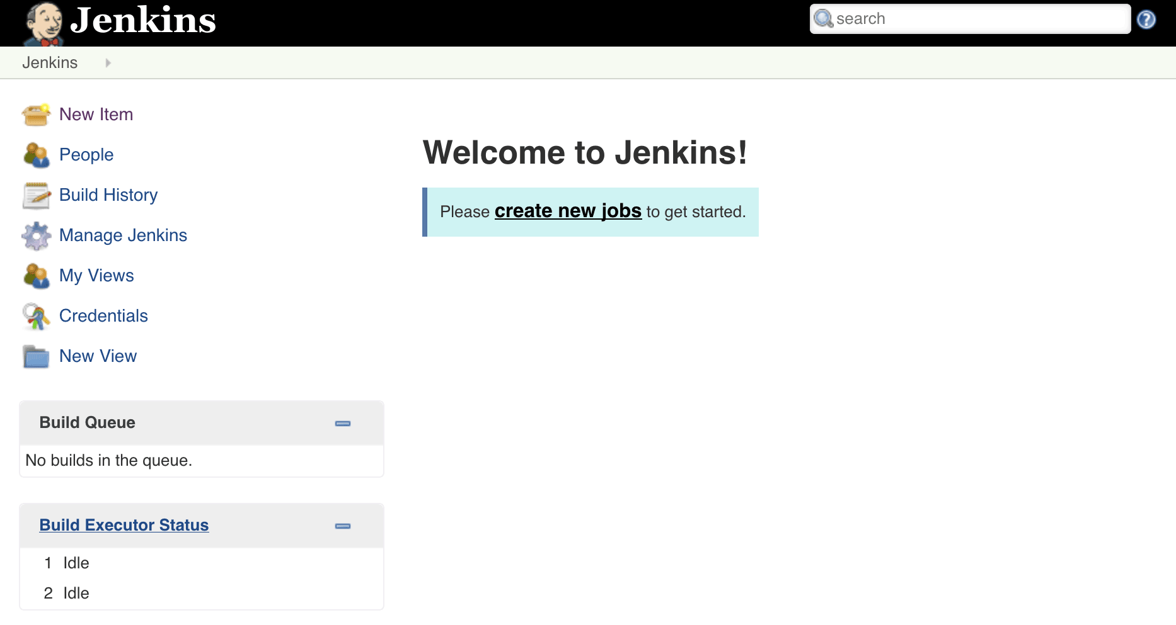

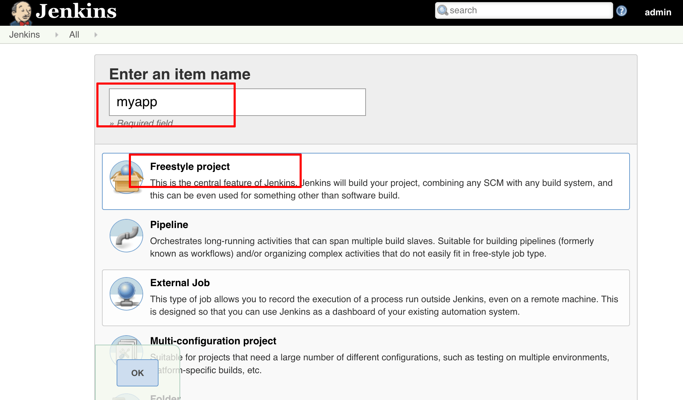

**Source Code Management**

* Go to Source Code Management Select git.
* There provide “**Git URL**” and Credentials and if you want give specific branch you can Mention **Branches to build**

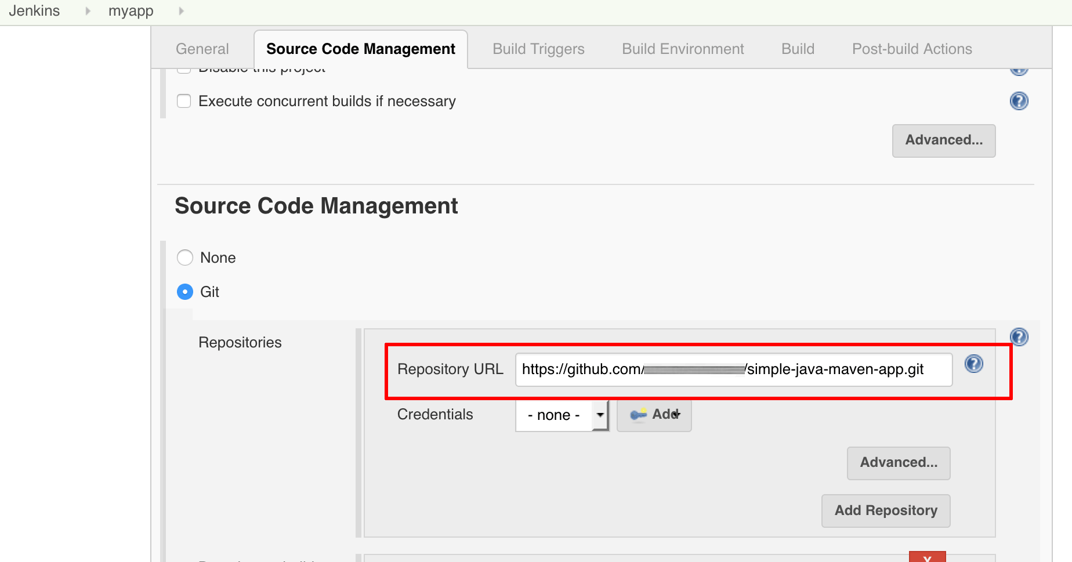

**Build Triggers**

* Hire you need to provide particular date and time [Cron Schedule]

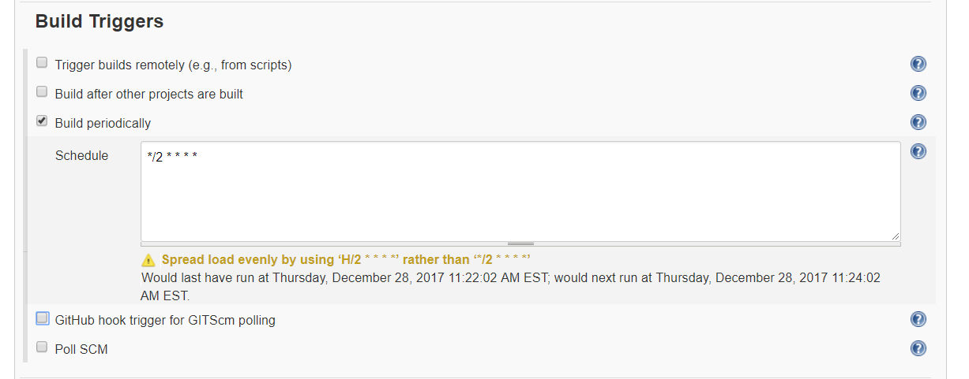

* It will trigger on that time

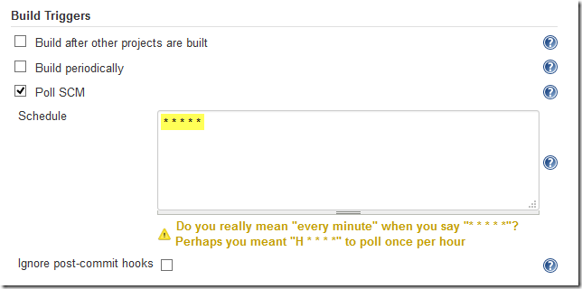

* There is a option called **Poll SCM** it will trigger every commit. Who made changes in local.

**Build**

* In this section build you code using shell script or any other tool like Maven

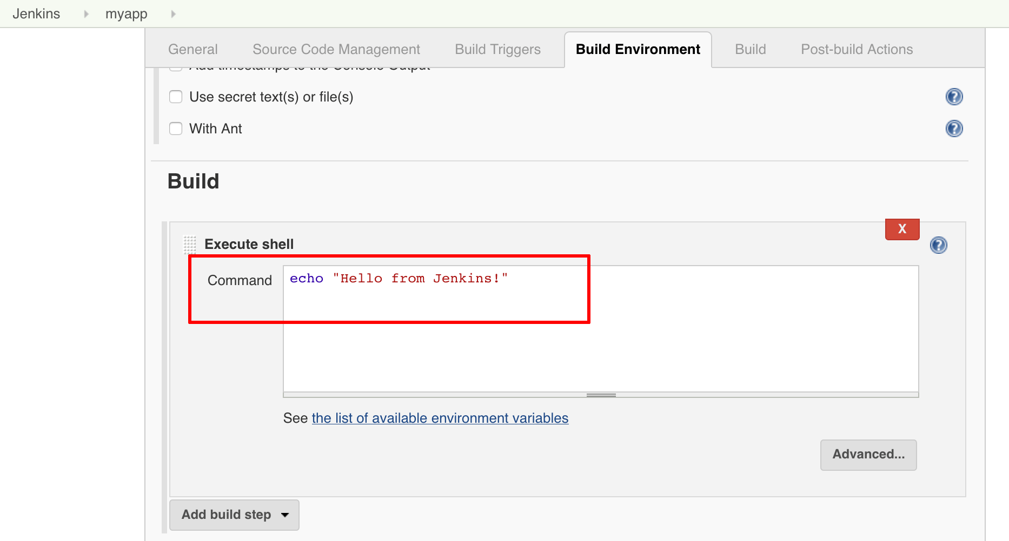

**Post-build Actions**

* In this section Deploy war/ear into webserver like apache tomcat, Jboss etc…
* Send out to Email Notification from this section.

